## Launch an EC2 Instance

1. Enter the name of the instance as below

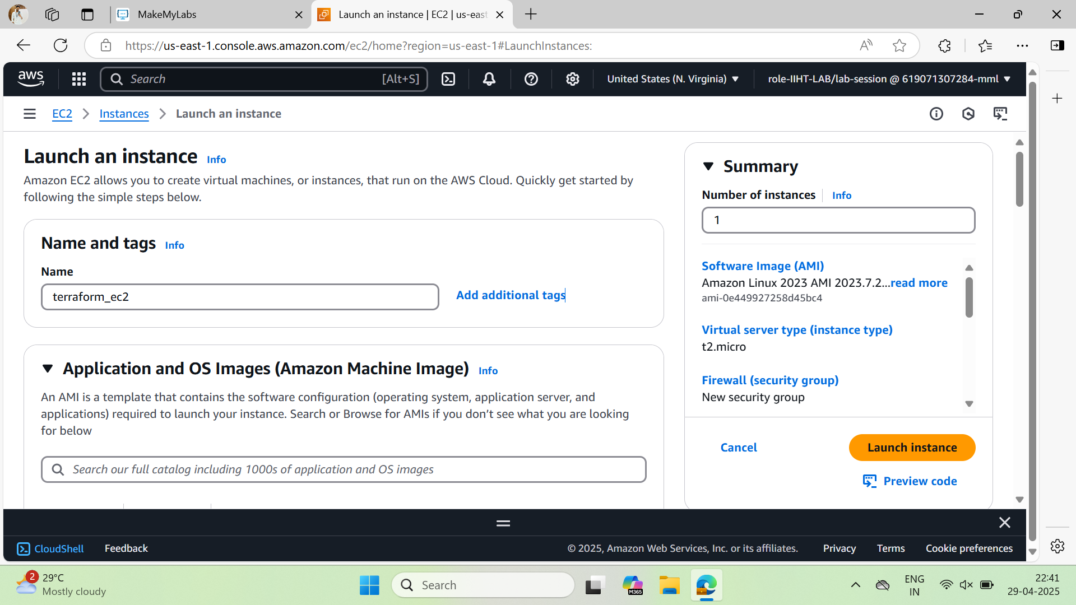

1. Select Amazon Linux OS

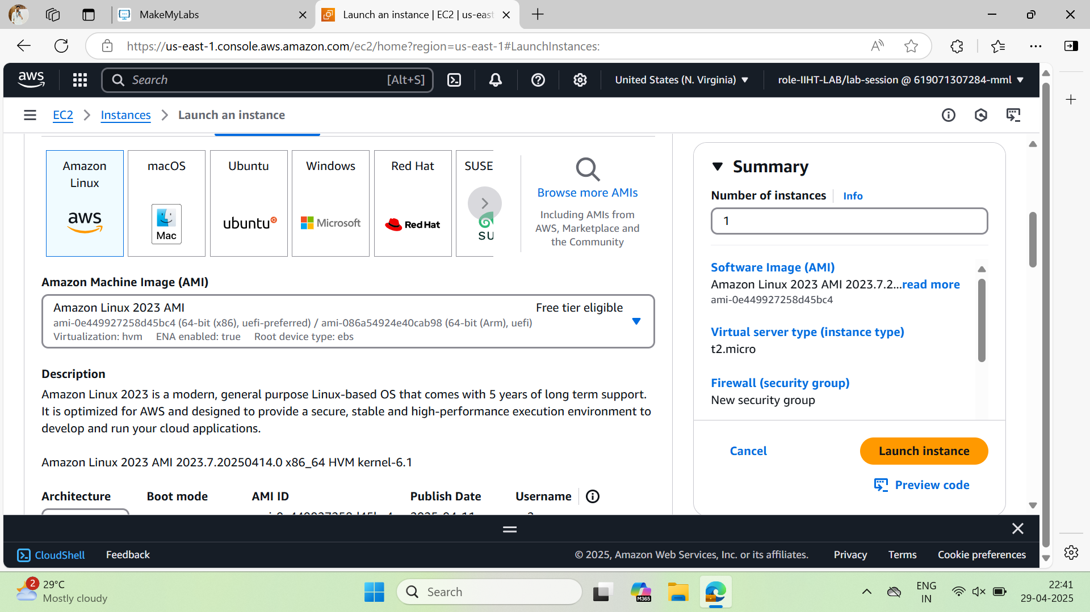

1. Select t2.medium machine type

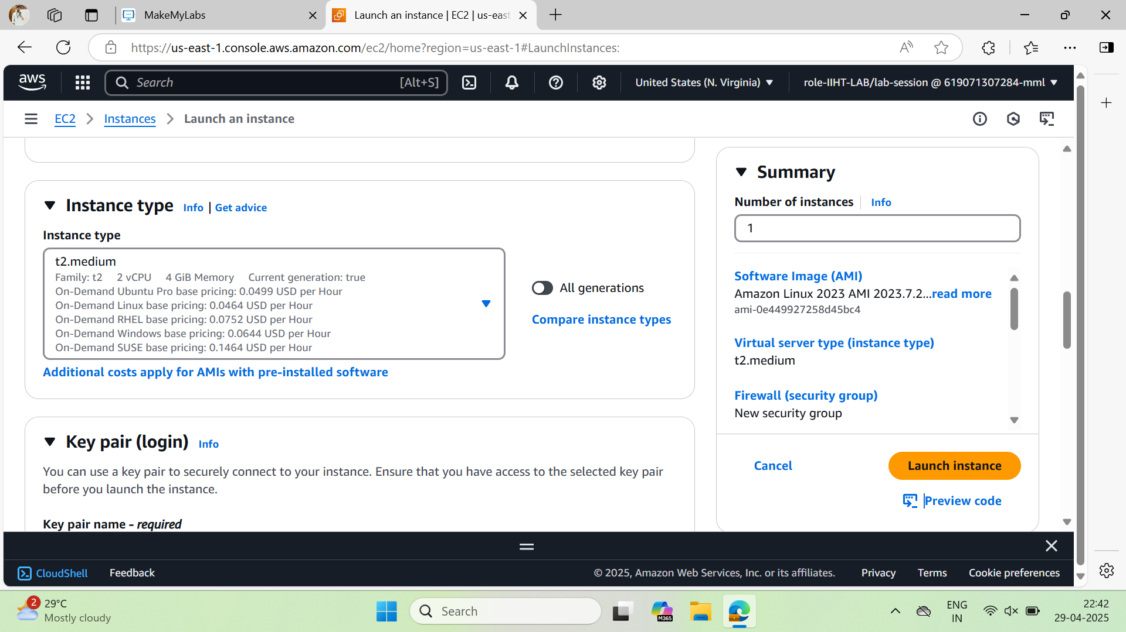

1. Select the key pair  
   Make you have in your local machine downloads,  
   If not create new key pair and download the **.pem** key file

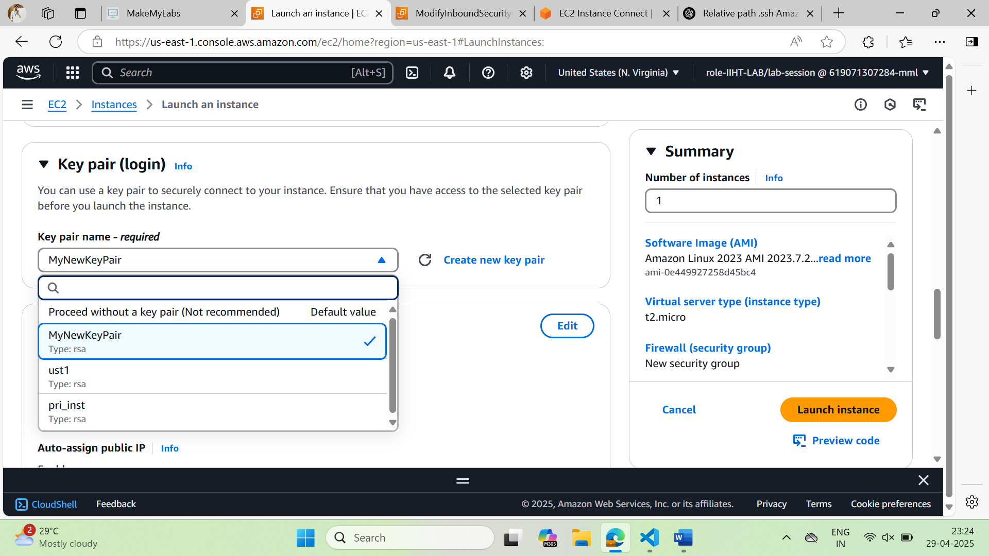

1. Select the security group which has the following inbound ports open  
   **22 port & 80 port**

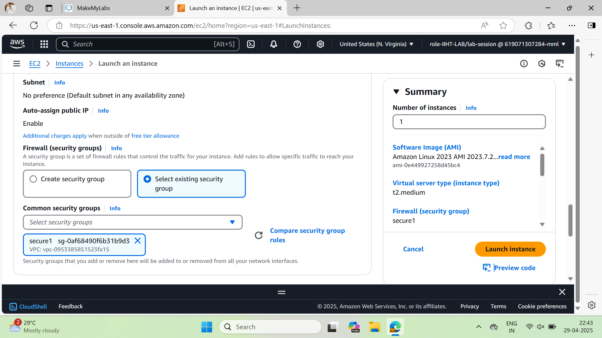

**Note :** If you don’t have an existing security group with the above ports or if you are unsure about ports create new security group and add the ports

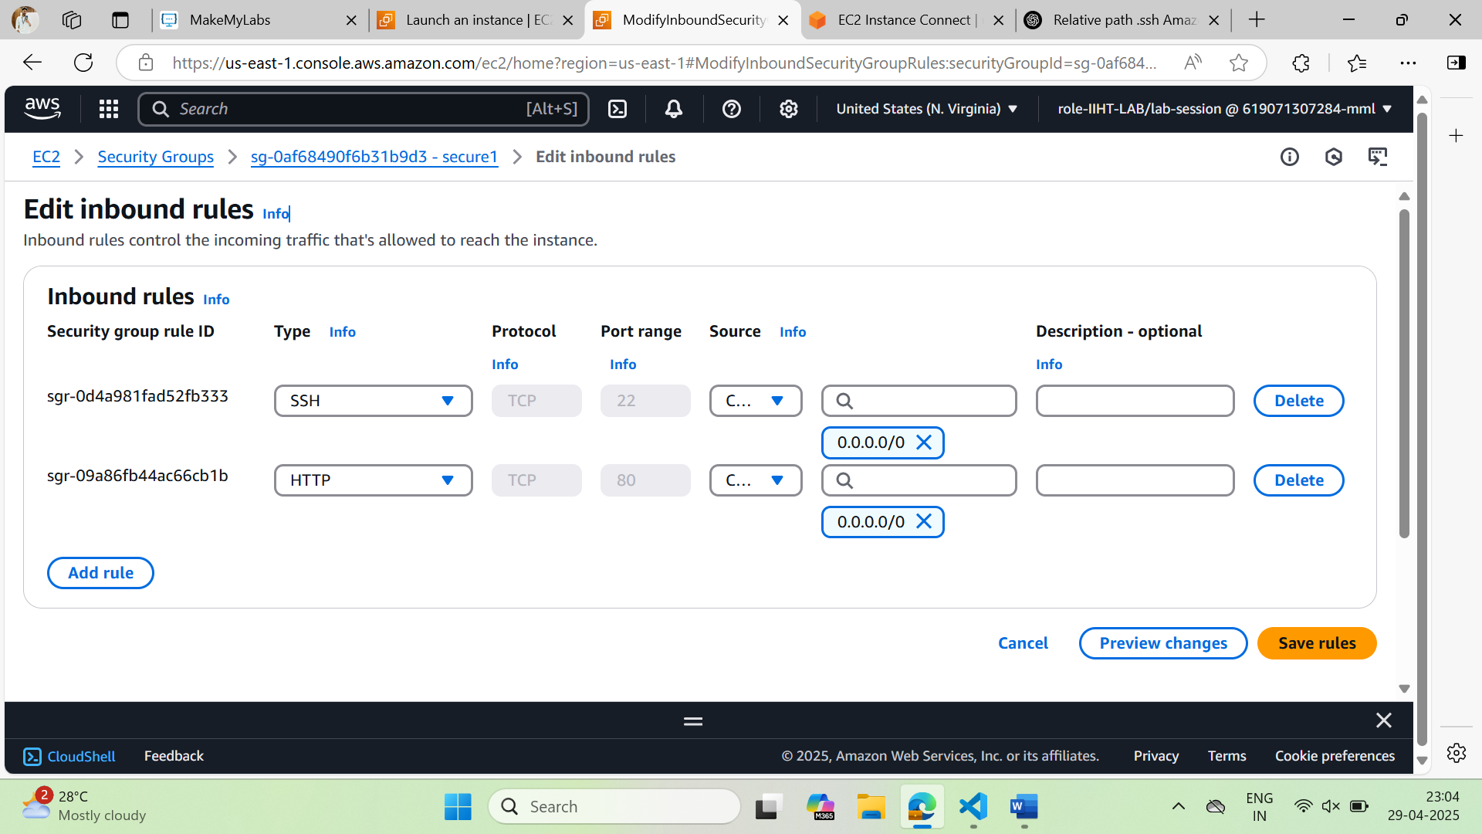

1. Click on **Launch Instance**
2. Now connect the Instance using console connect option

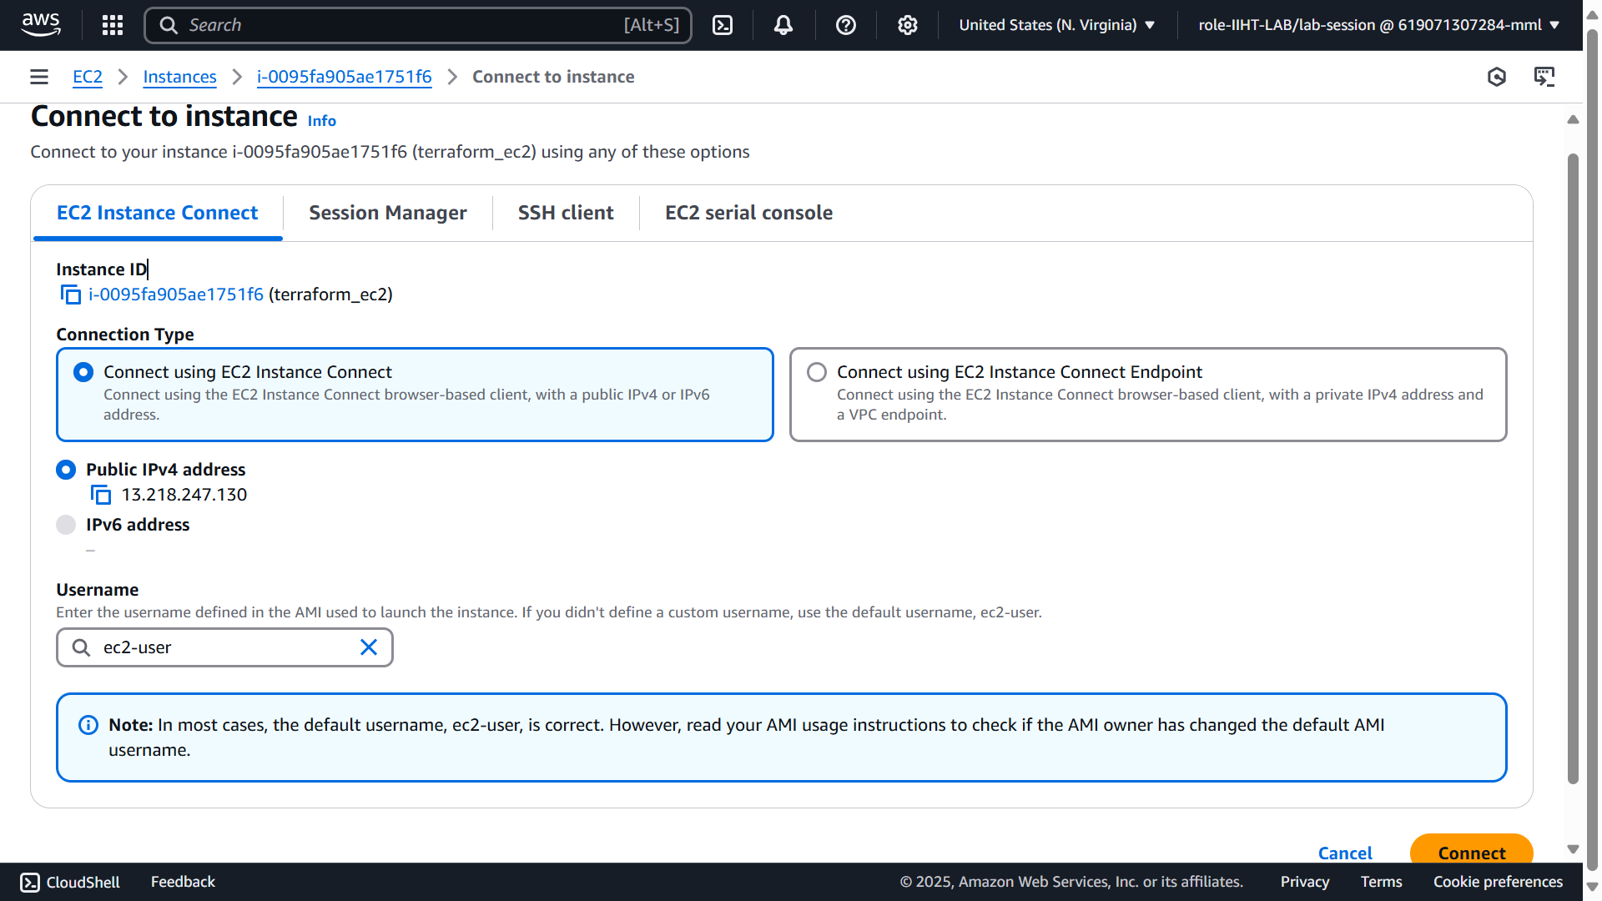

**Note:** If you are unable to connect to the instance using connect option, check the security group inbound rules weather you added the **22, SSH port**

1. Enter *sudo su* for superuser privillages
2. Enter the following command to edit the sshd config file  
   *nano /etc/ssh/sshd_config*

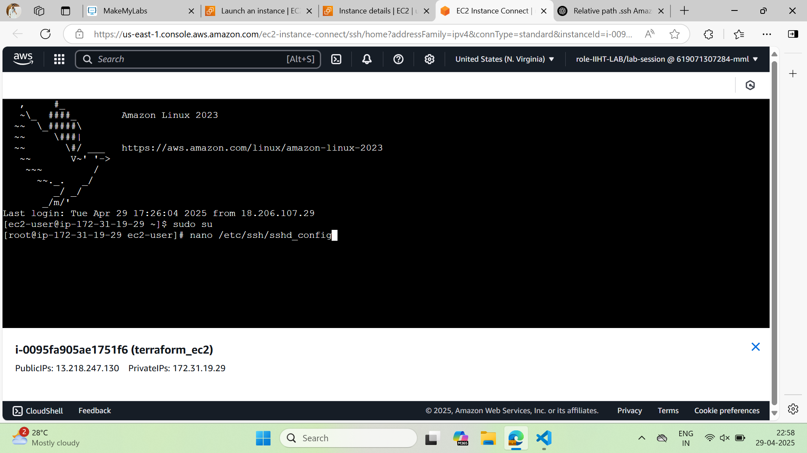

1. You can see the **sshd_config** file opened in the nano editor

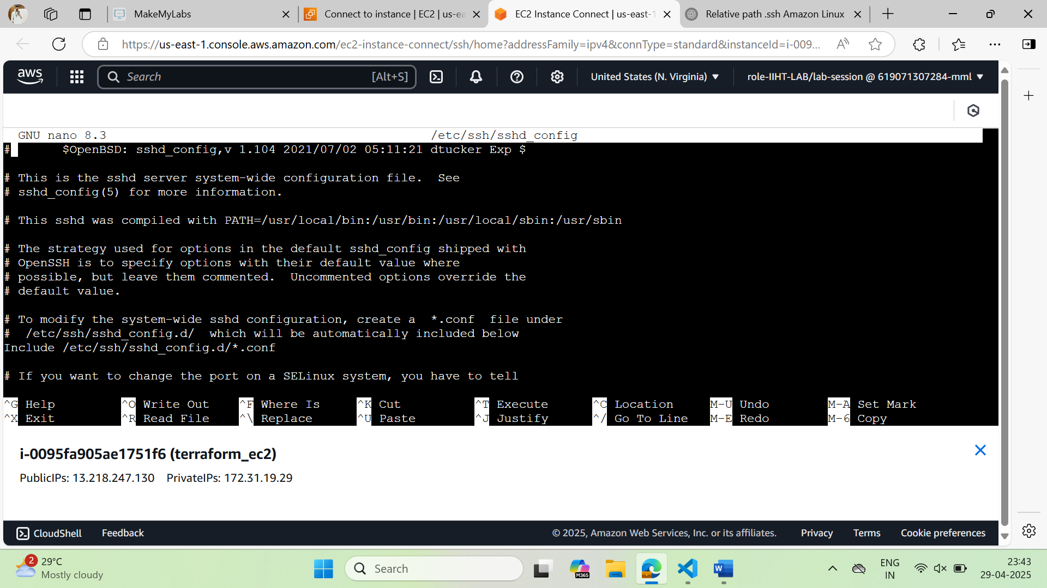

1. Scroll down a little and you can find the Port 22 commented down

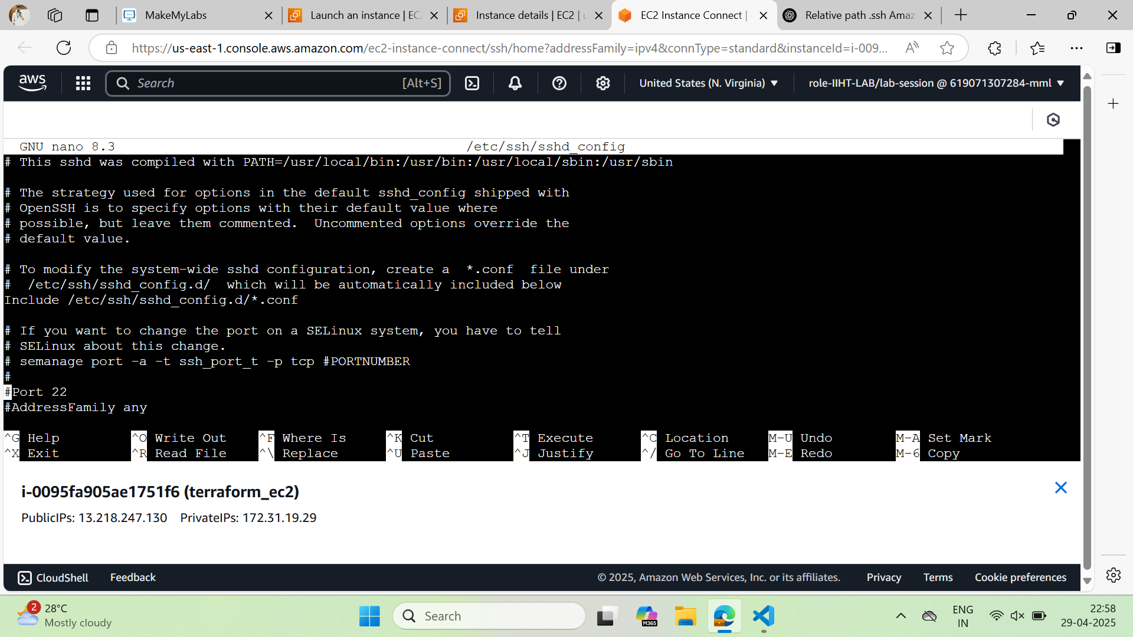

1. Uncomment ( remove the “**#**”) before the Port 22 and change the **22 to 80**

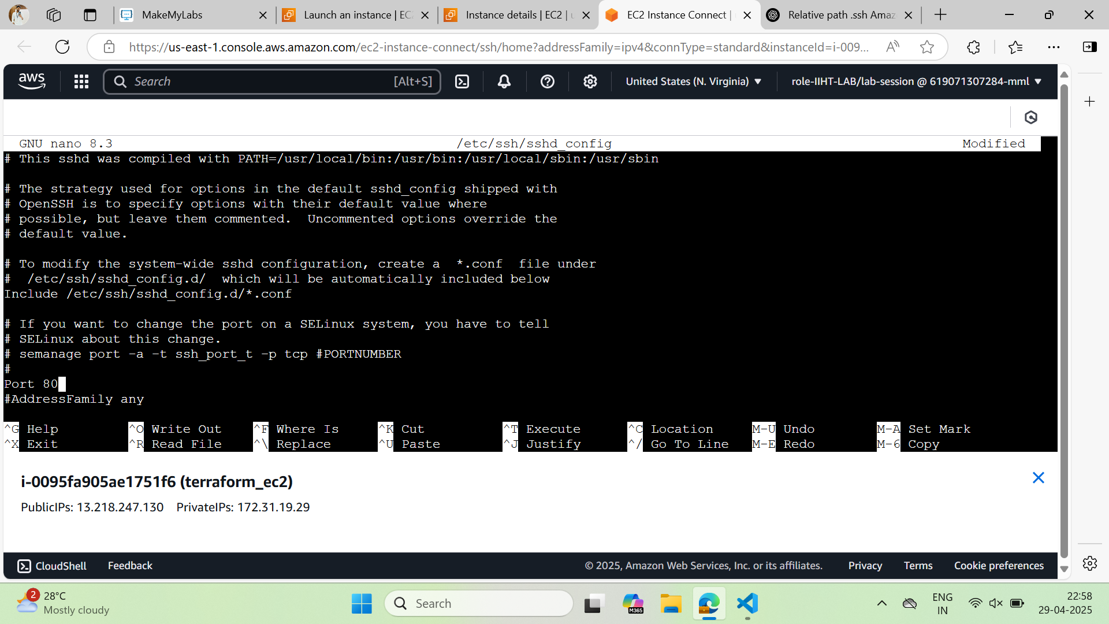

**Note:** Be cautious while editing this file, since this is a config file, any mistake leads to errors.

1. Save the sshd_config file  
   Click **Cntrl + O** tosave the file
2. Exit the editor  
   Click **Cntrl + X** to exit the editor

## Installing Terraform on the ec2 Instance

Before doing this come to the home directory of the machine by entering following command

**cd /home/ec2-user**

1. Run the following command to install **unzip** package  
   **sudo yum install -y unzip**

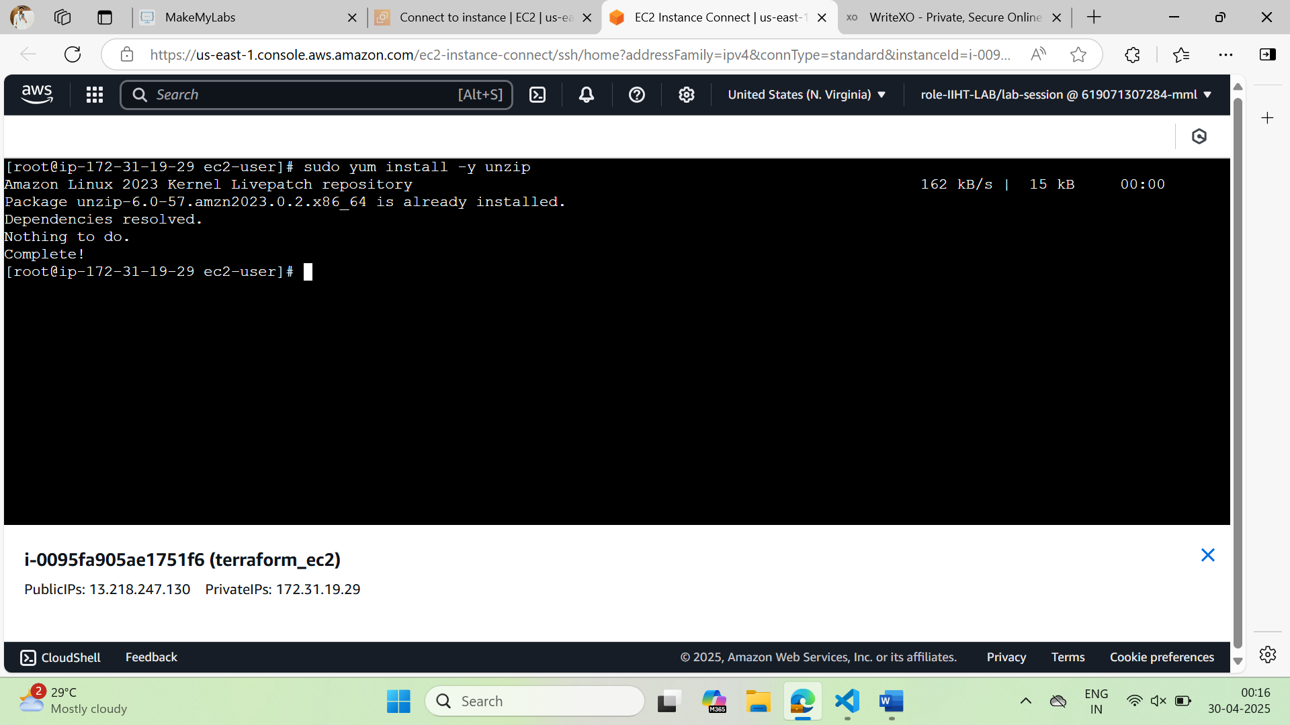

1. Run the following command to download the terraform zip file

*curl -LO* [*https://releases.hashicorp.com/terraform/1.11.4/terraform_1.11.4_linux_amd64.zip*](https://releases.hashicorp.com/terraform/1.11.4/terraform_1.11.4_linux_amd64.zip)

You should find a zip as shown below when you run **ls** command.

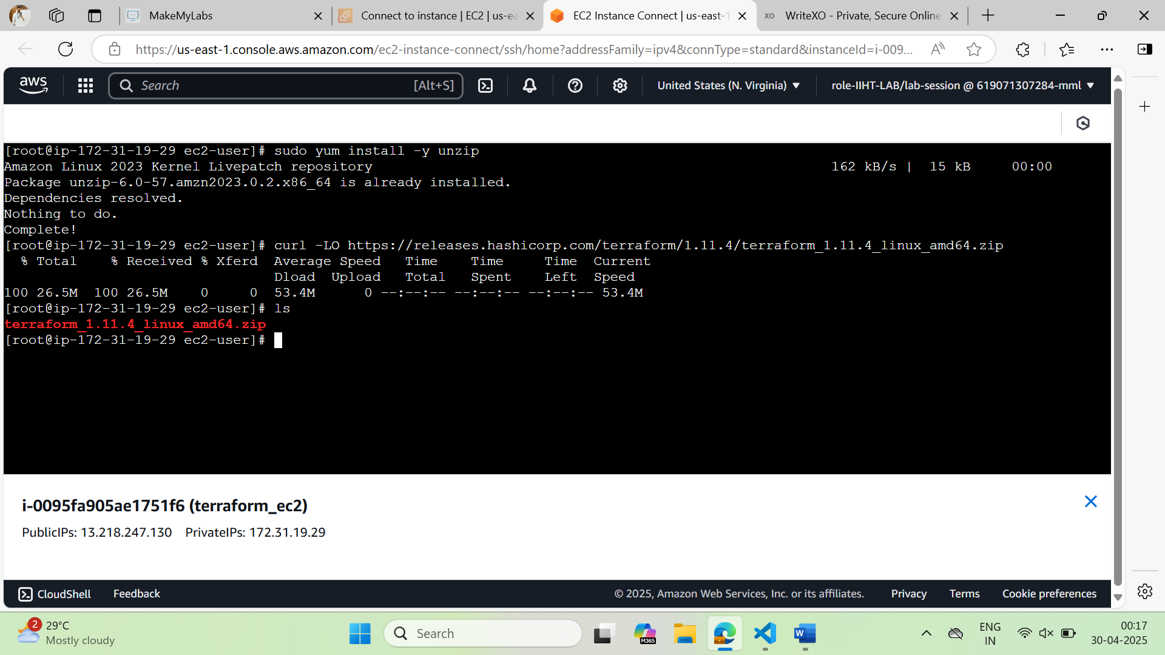

1. Unzip the download zip file using the following command  
   *unzip terraform_1.11.4_linux_amd64.zip*

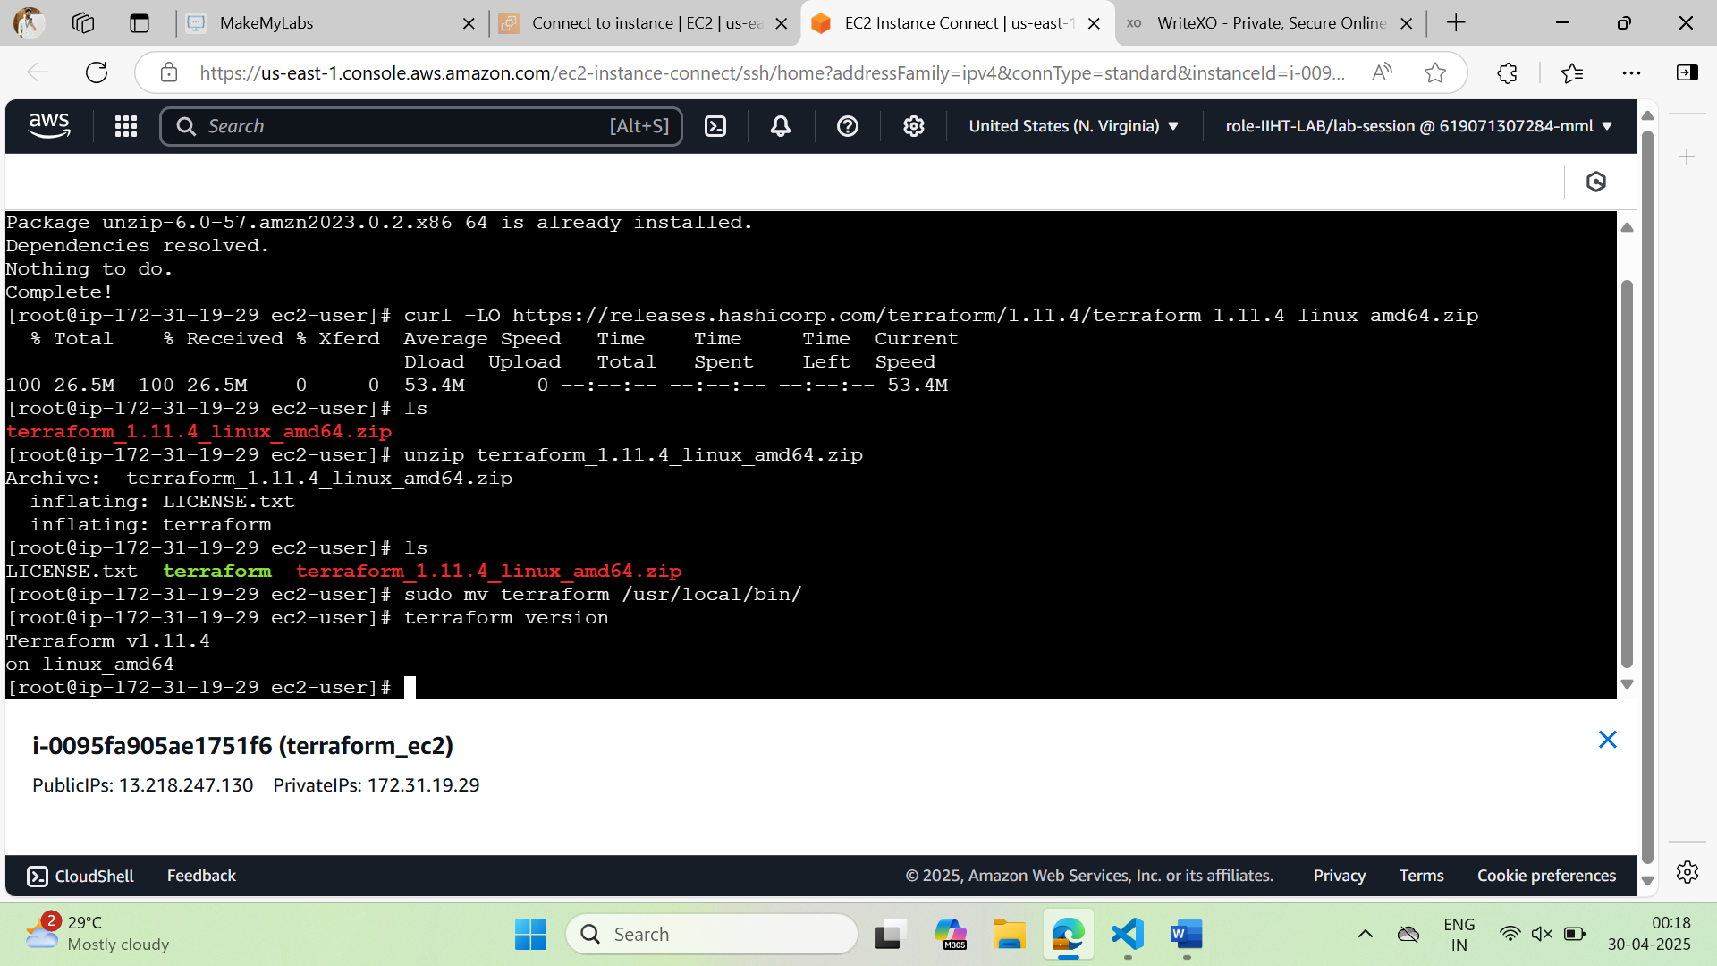

1. Move the folder to usr/local/bin   
   sudo mv terraform /usr/local/bin/



1. Check terraform installation by entering the following command  
   **terraform version**



## Now try connecting to your ec2 instance from your local machine

1. Open git bash or Powershell and try connecting to ec2 instance using ssh
2. Navigate to the folder where you have your public key of the instance (key pair associated to the instance)
3. Enter the following command  
   ssh -i <key_pair_name> -p 80 ec2-user@<public-ip-of-ec2-instance>  
   **example: ssh -i my_ec2_key.pem -p 80 ec2-user@13.218.247.130**  
   if you are prompted to continue connecting,  
   Type **yes** and click **enter**
4. If you see the following then you are all set to go to next step

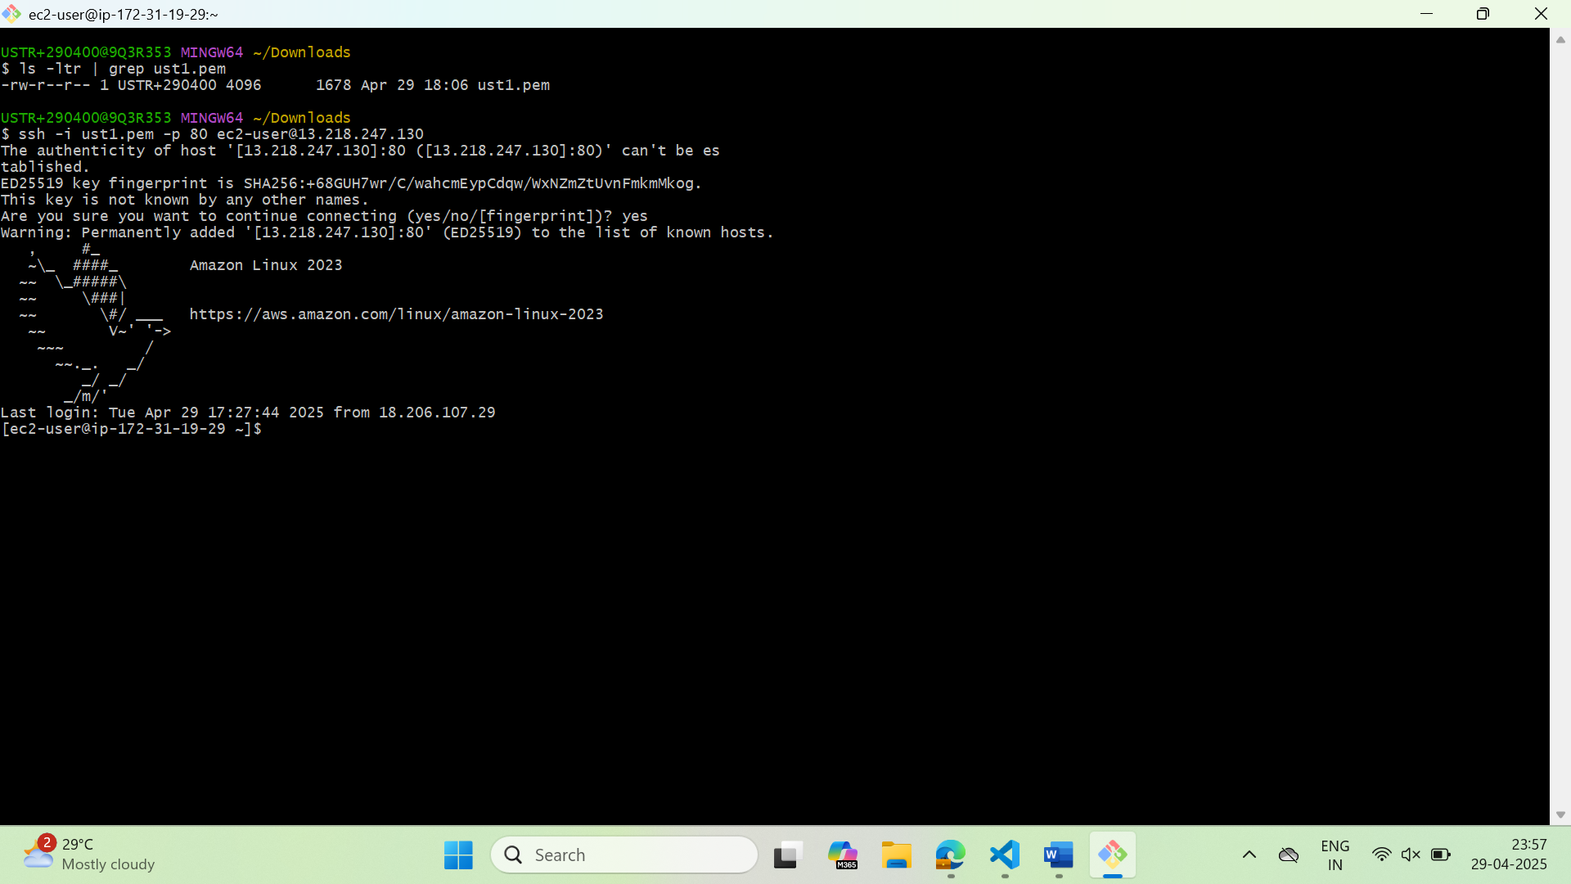

## Installing Extensions to vs code

1. Open your vs code and install the following extensions  
   Click on Extensions in the sidebar  
   Enter “**Remote SSH**” in the search top  
   Select the first one.  
   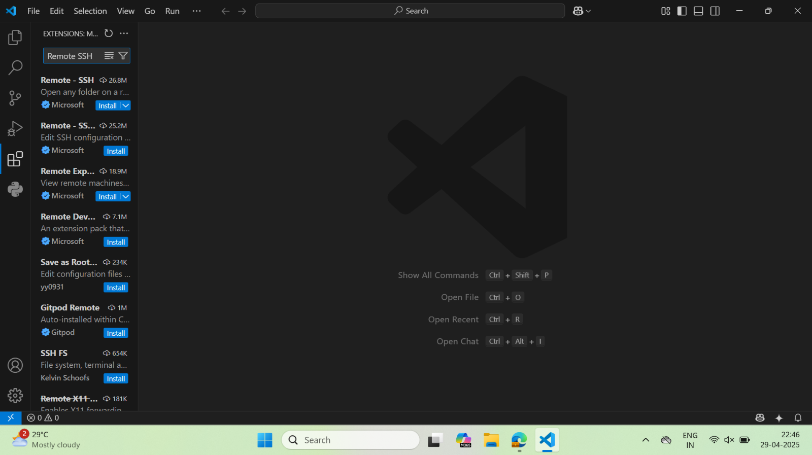
2. Click on Install

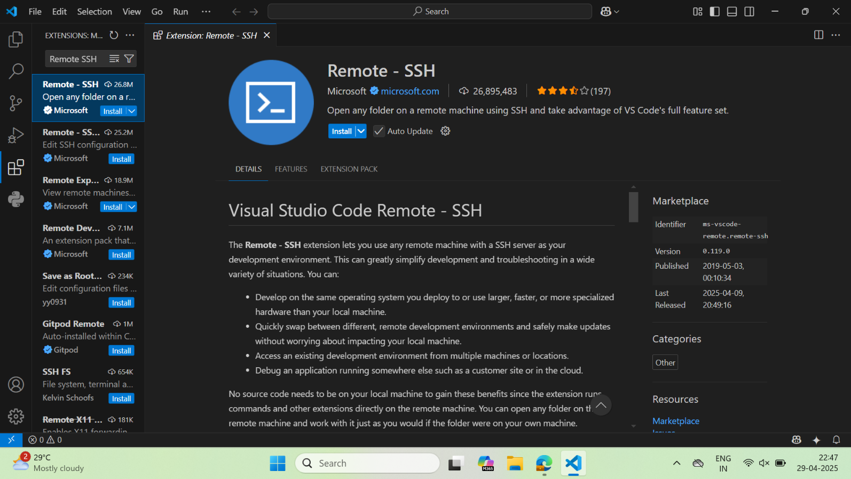

1. Install HashiCorp Terraform Extension  
   Search HashiCorp in the search bar  
   Click on first one  
   Click on Install

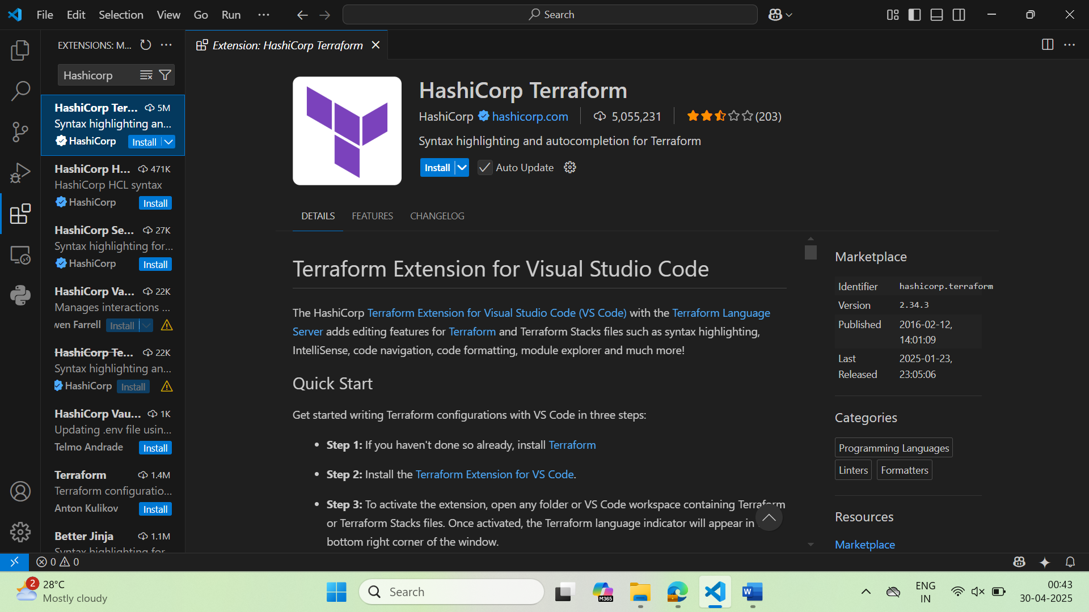

1. Install AWS Toolkit Extension  
   search **aws toolkit** in the extension search bar  
   Click on the first one and click on Install

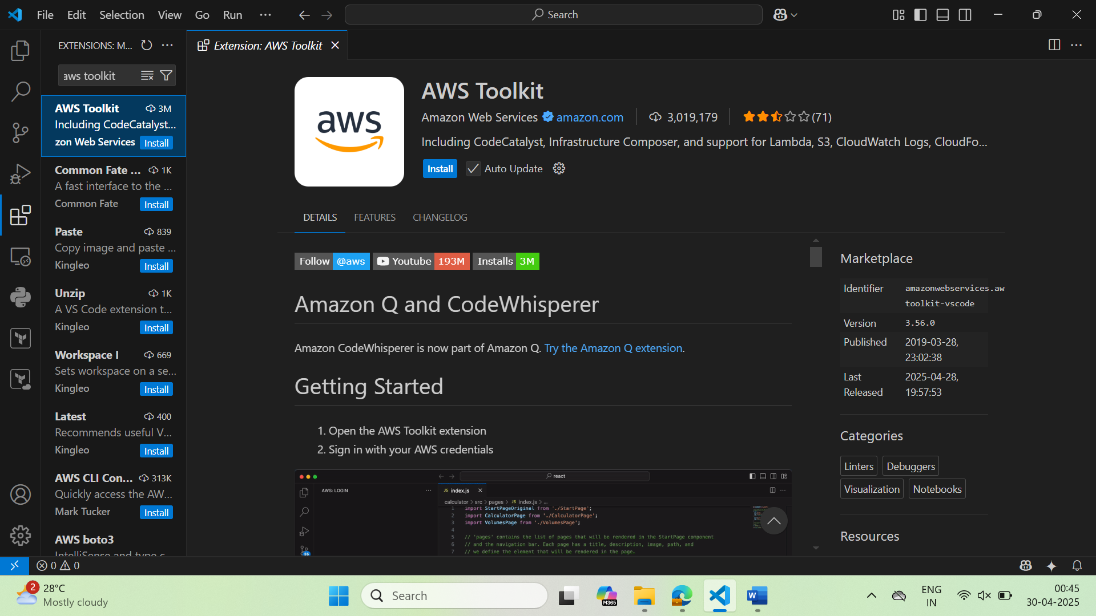

## Connecting your ec2 from vscode

1. Copy the pem file to the .ssh folder of your local machine  
   Execute the command in git bash and check the paths of the pem file and .ssh folder before copying  
   cp <pem file path> <.ssh folder path>  
   **Example:-**Here In my case I have the pem file in my Downloads folder  
   Make sure you are in the home directory of the user (your employee id user)

Run the following command if you are in the same path and you have your pem file in the **Downloads** folder

1. pwd   
   check you are at the home directory of user  
   here its: /c/Users/290400
2. ls .ssh  
   to check you have the folder and it has config file in it
3. cp Downloads/ust1.pem .ssh  
   copies the pem file to the .ssh folder
4. ls .ssh  
   checking weather copy is successful

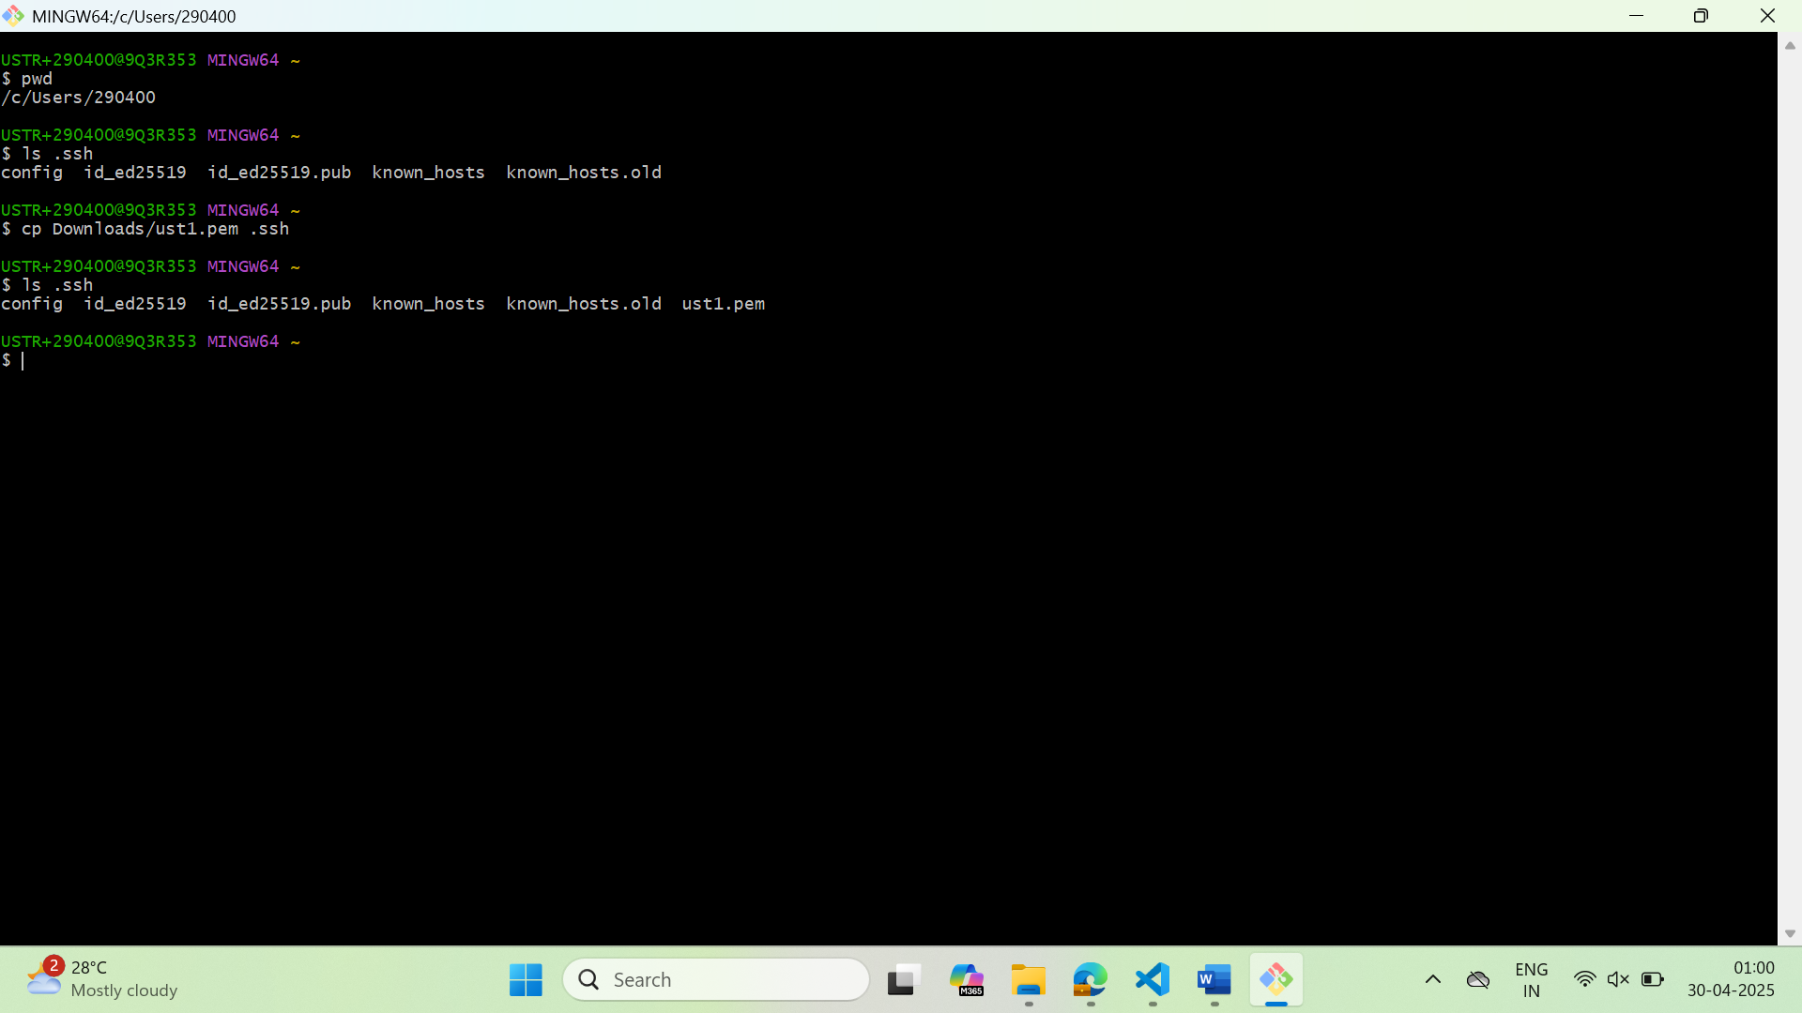

Now the relative path of the pem file should be something like below:  
**~/.ssh/ust1.pem** (replace with your key name)  
make a note, we need it in the next step

### In vscode click F1 (check whether you have turned fn lock)

Enter Remote SSH in the search bar and select Remote SSH as shown below

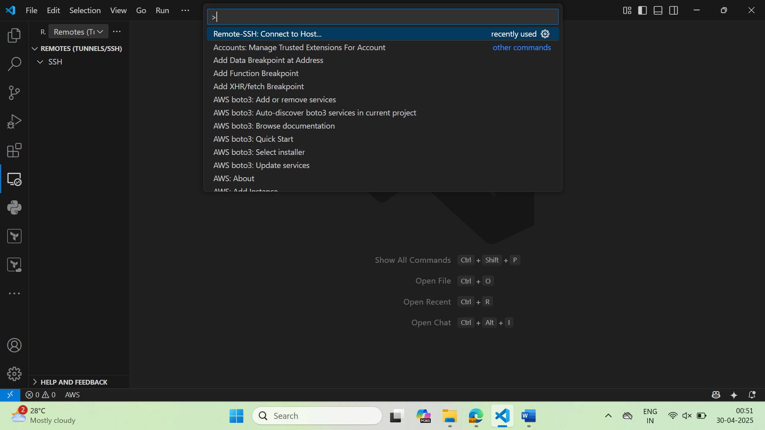

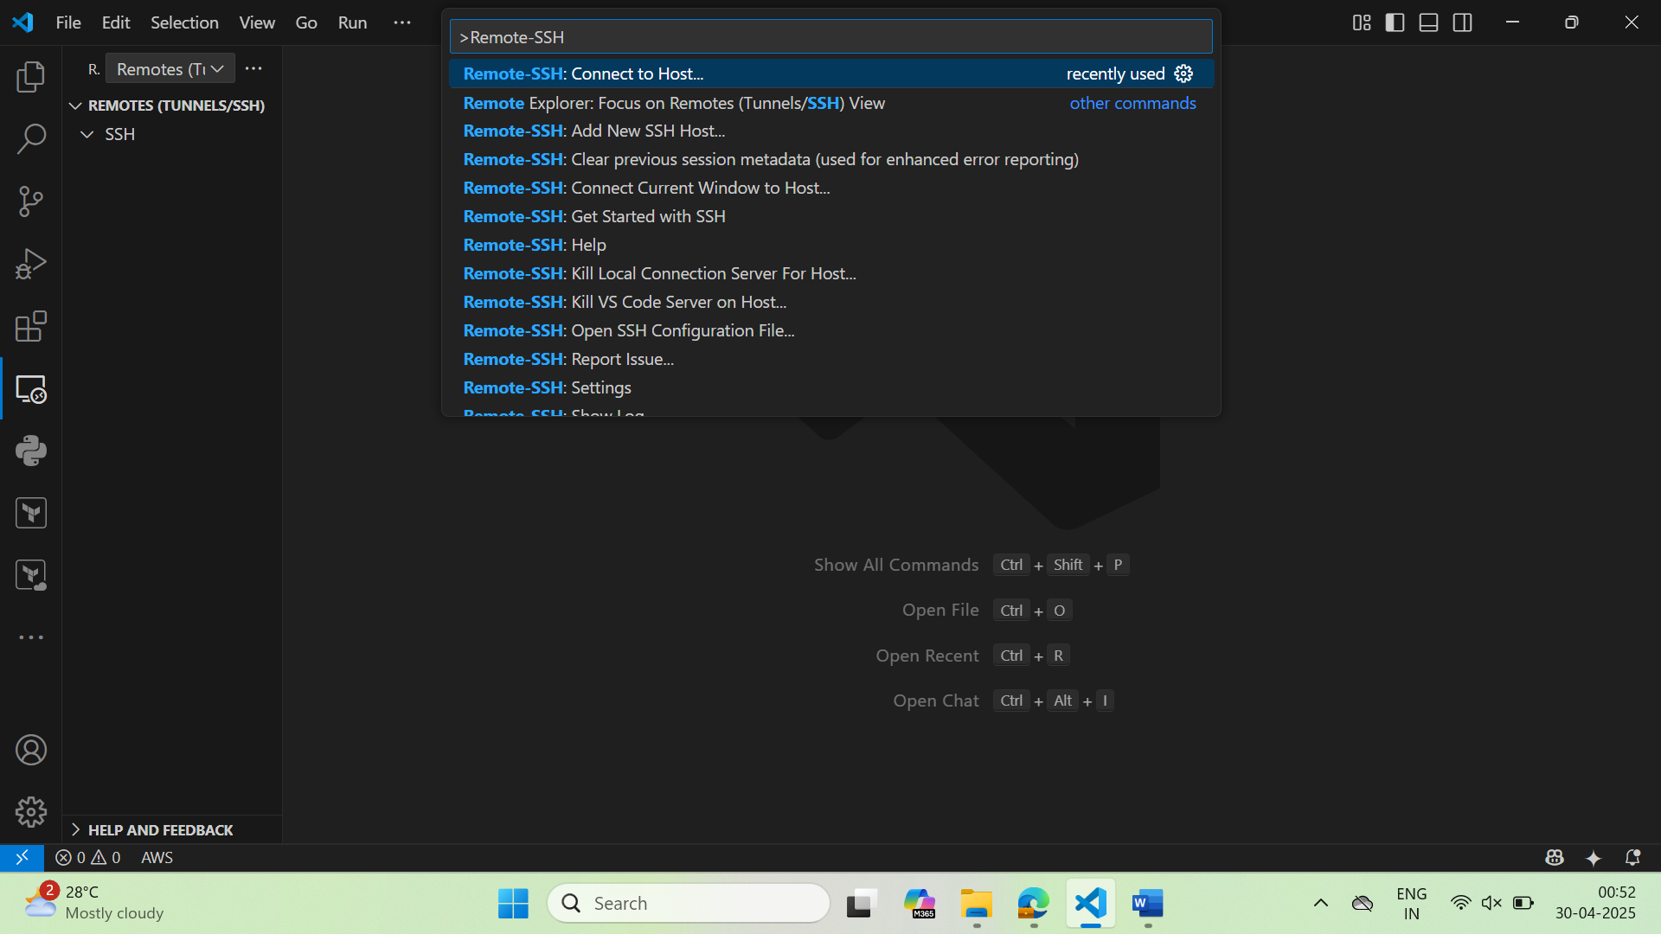

Now you will be shown 2 options like this, select first option i.e., **+Add New SSH Host..**

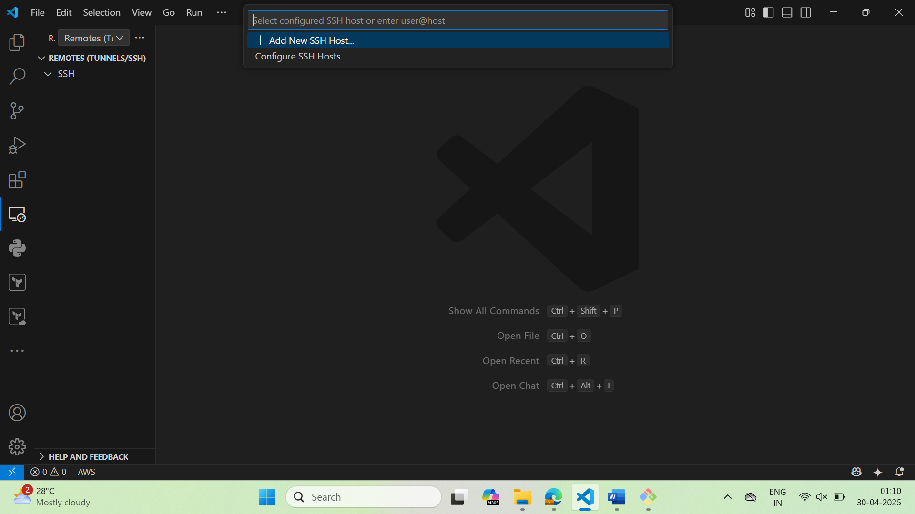

Then Enter the following command by replacing your key-pair (pem file) name and your ec2 instance public IP

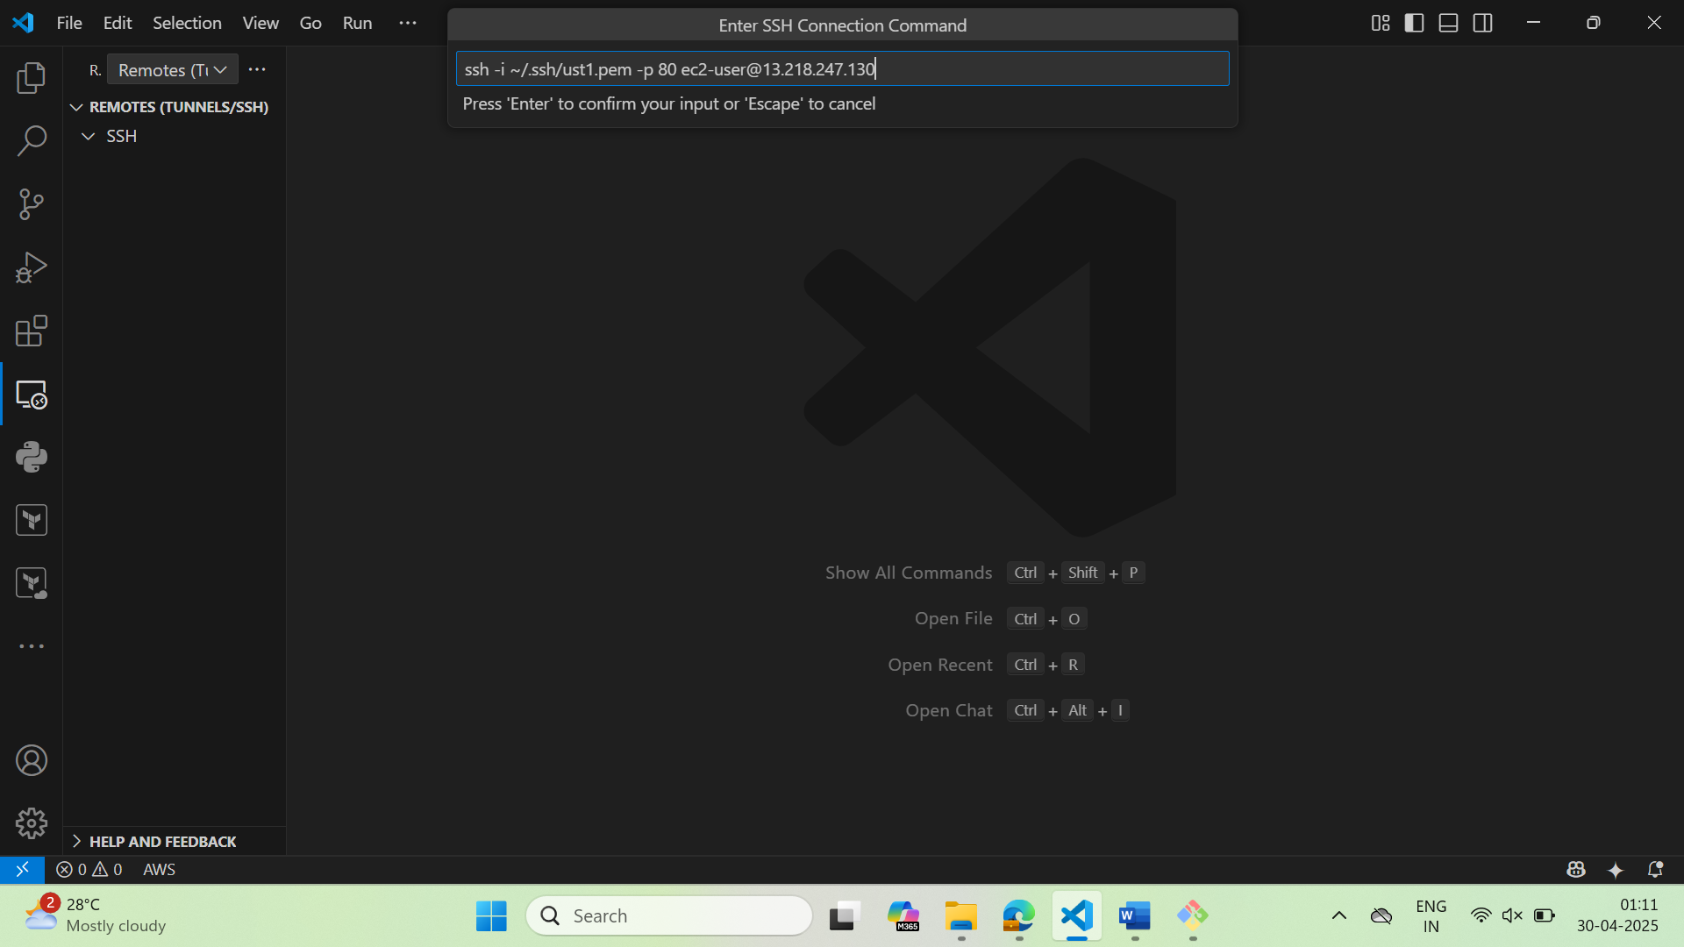

Now select the ssh config where the Host details should be added  
Select the first one (.ssh folder should be present in your home directory of user)

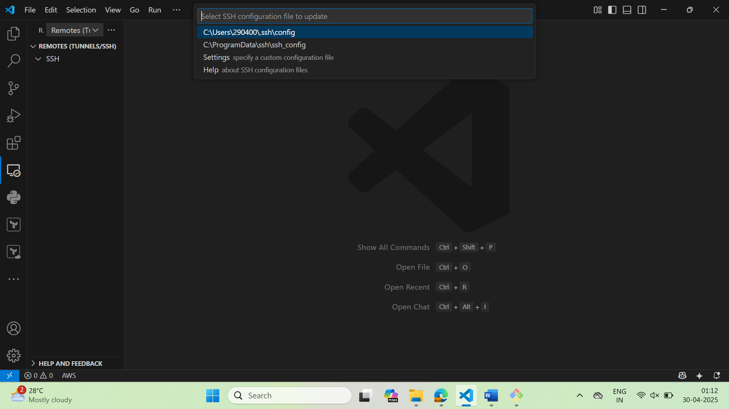

After that you should be able to see the Public IP in the left side as below (if adding host is successful)

You will be prompted to connect to the instance on the right bottom, click on connect

**Note:** If you miss the above option you can choose the connect option present in the left side as below (click on right pointing arrow beside the Public IP)

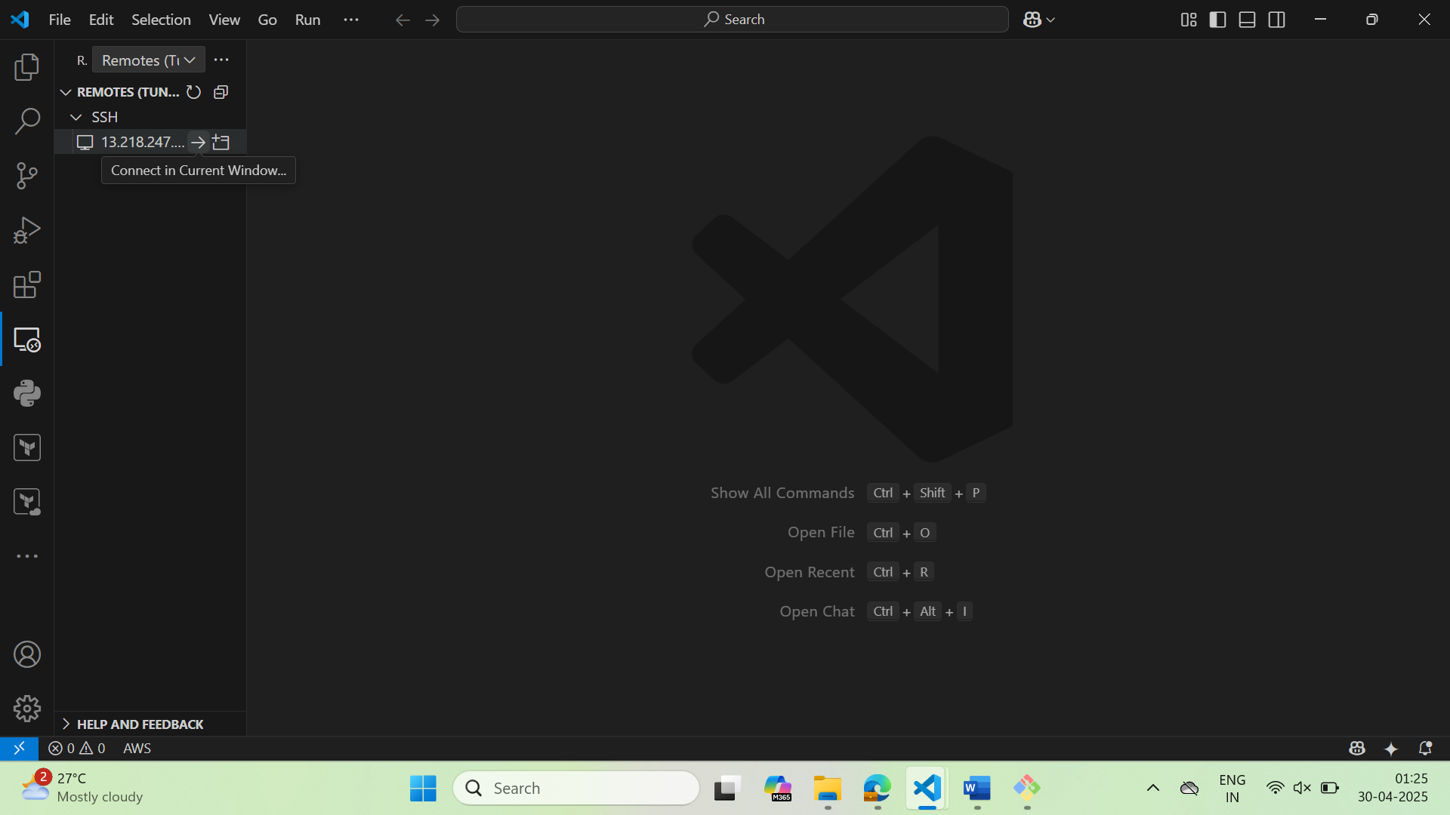

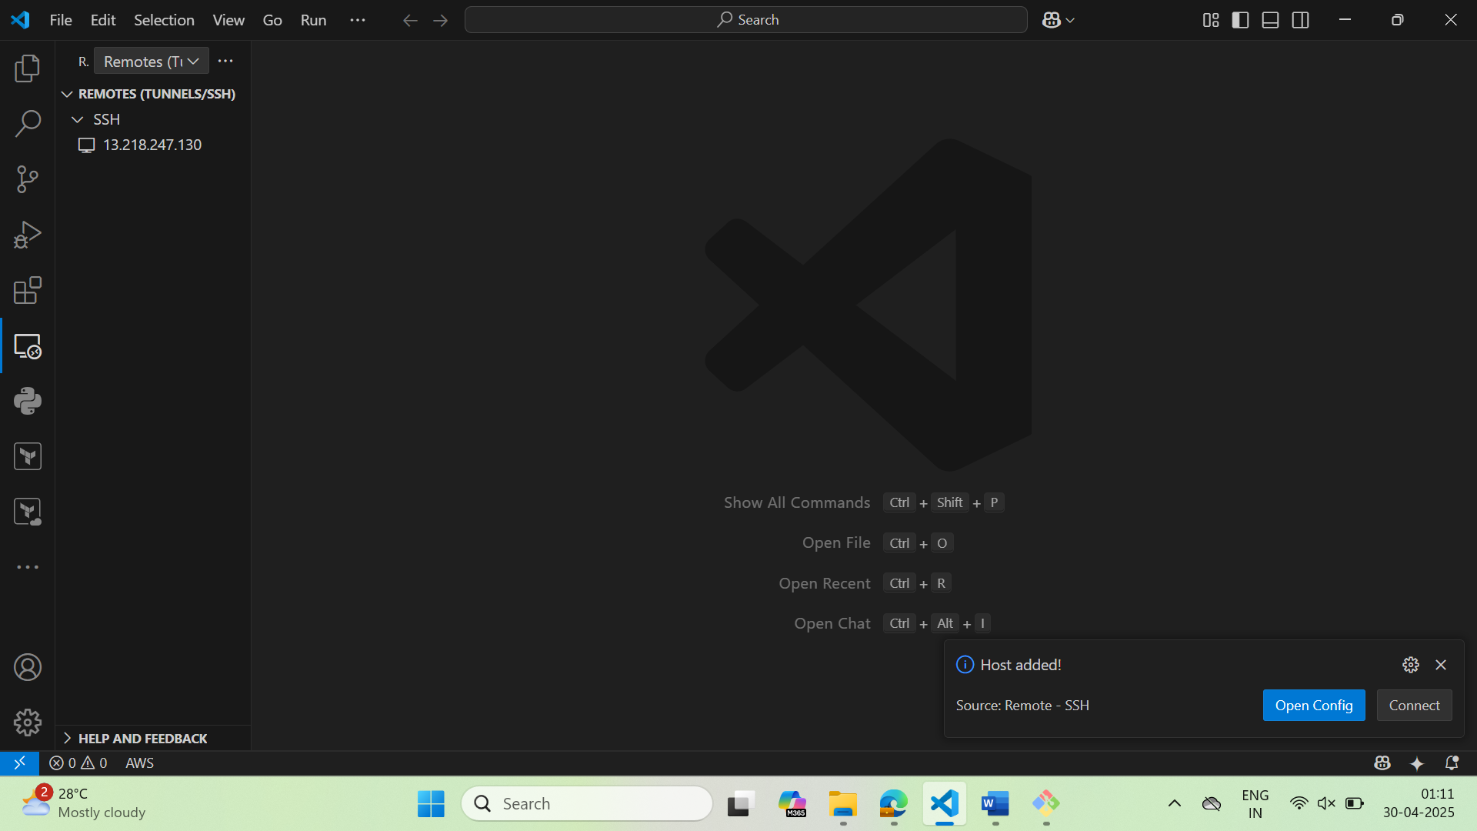

A new window will be opened and select the folder to be open from the Remote ec2 instance

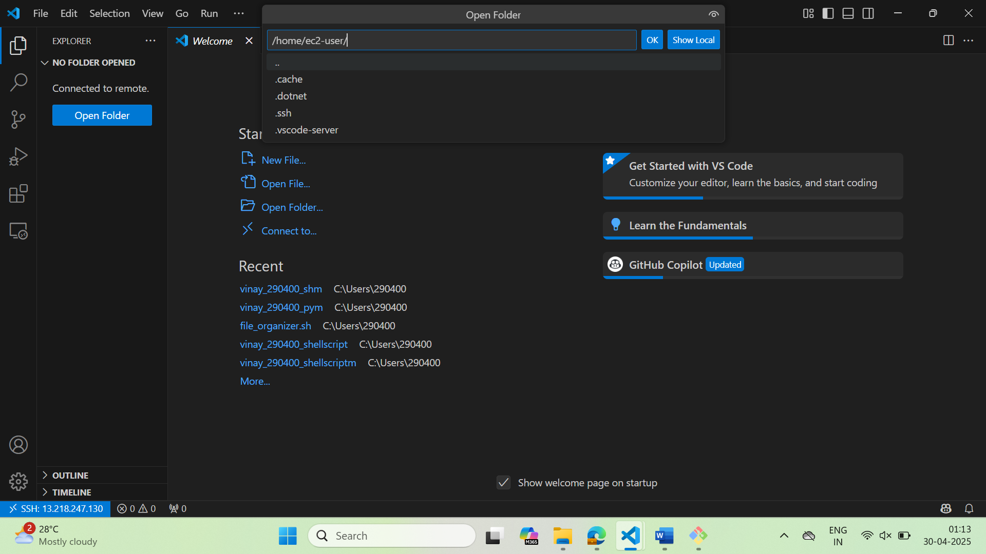

If everything works well you will get the folders as below

